French legislation describing dam-break wave computations

**Arthur Guillot – Le Goff  
15/01/2022**

Table des matières

Short review of French hydraulic structures 2

Regulation around dams 3

Dam-break wave computation 4

📚 Bibliography 6

🖼️ List of figures 6

*Hydraulic modelling   
Semester of Autumn 2021*

# Short review of French hydraulic structures

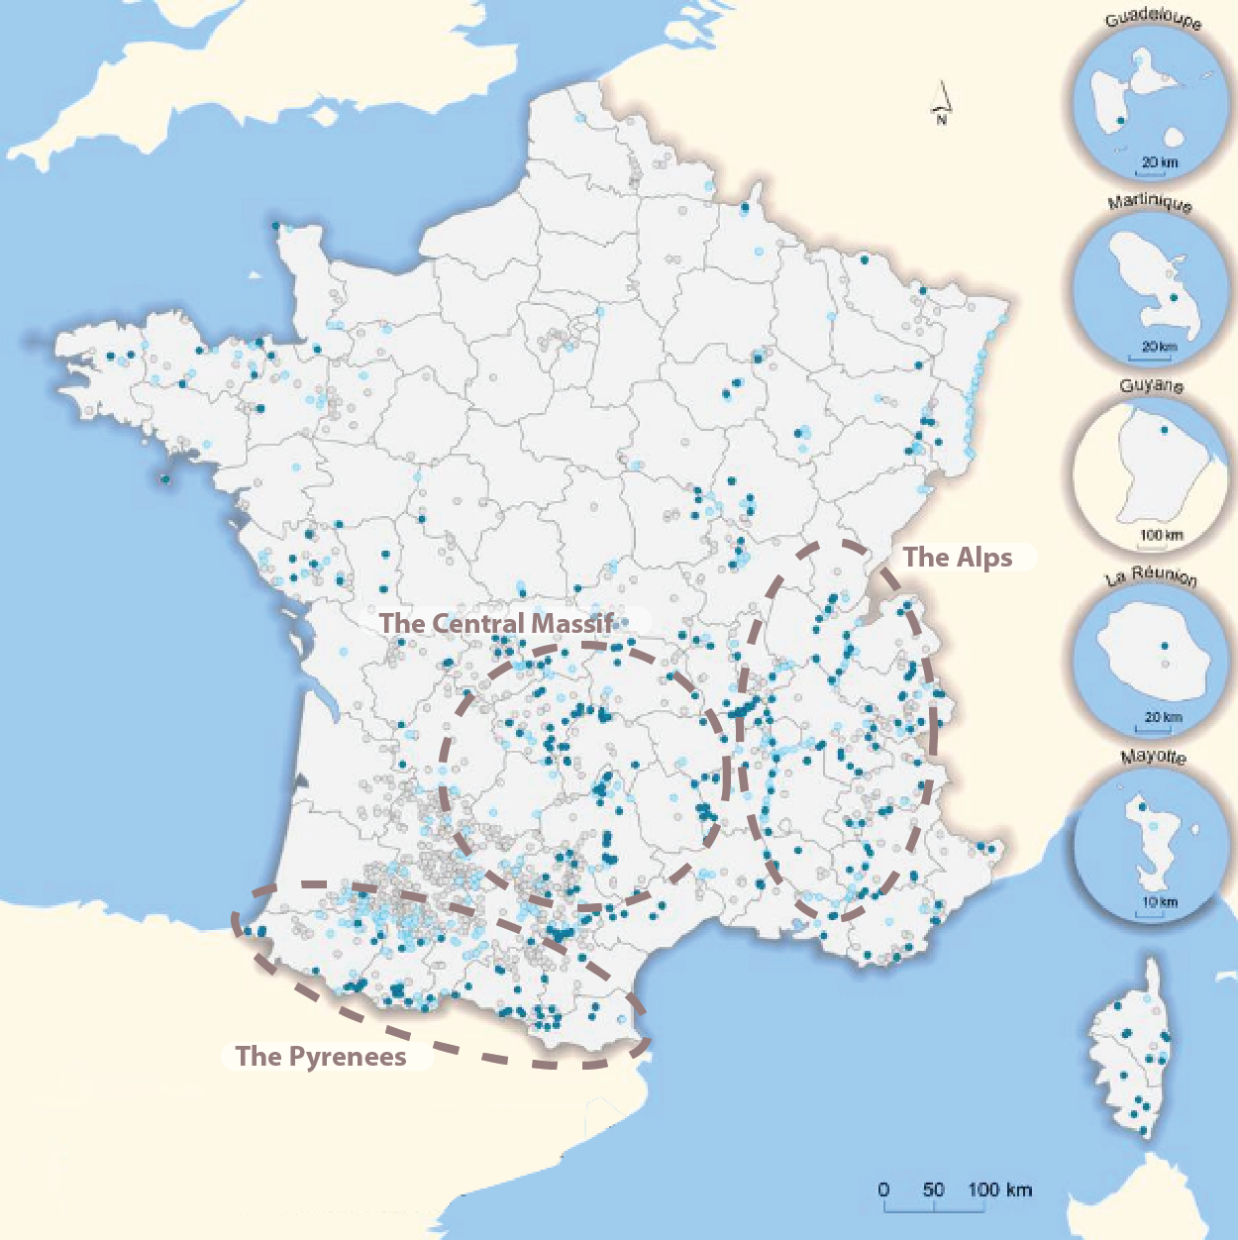

Figure 1 - Location of dams in France (sources: MEDDTL, DGPR, IGN)

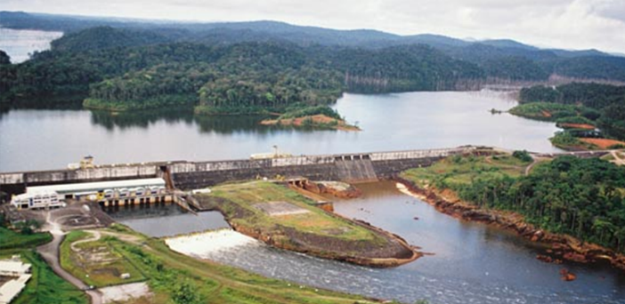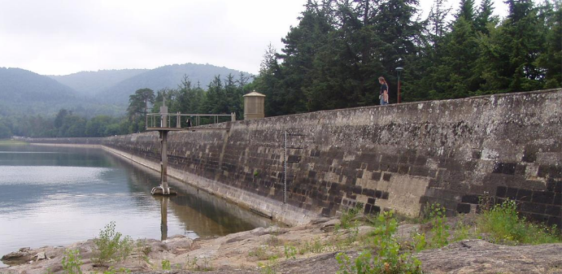In France there are more than 500 dams that reach than 15 metres above the natural terrain and a large number of smaller dams (mainly used for agricultural purposes). The French territory benefits from an already well exploited hydroelectric potential. Indeed, the exploitable potential is estimated at 70 TW.h/year and in 2020 63.5 70 TW.h/year have been exploited. This potential is spread over three main basins: The Alps, the Pyrenees and the Massif Central. Overall, hydroelectric production represents 13% of total French production and 9.7% of European production (the third largest European producer). There are many remarkable structures in France, including the Saint-Ferréol dam (the oldest French dam, 1663), the Tignes dam (the highest, 160m) and the Petit Saut (the largest reservoir, 3500 Metropolitan Francemillion of m³).

Figure 2 - The Petit Saut dam (Saint-Élie, Guyane)

Figure 3 - The Saint-Ferréol Dam (Auvergne-Rhône-Alpes, Metropolitan France)

In France and according to the article R214-112 of (Chapitre IV : Activités, Installations et Usage (Articles R214-1 à R214-132), 2019)the classification of dams is divided into three categories according to its geometrical characteristics :

|  |  |
| --- | --- |
| **Category** | **Geometrical characteristics** |
| A | and |
| B | Work not classified as A and for which and |
| C | Work not classified as A or B and for which and  Work for which the conditions in a are not met but which meets the following cumulative conditions: |

Table 1 - Categorisation of French dams

Where:

* , is the height of the structure expressed in metres and defined as the greatest height measured vertically between the top of the structure and the natural ground level at the top,
* , is the volume retained expressed in millions of cubic metres and defined as the volume that is retained by the dam at the dam at the normal retention level.

According to the article R214-115 of the same legislation, only the category A and B are affected by the obligation to carry out a hazard study, which is of interest to us when it comes to modelling dam-break wave.

# Regulation around dams

In France, the failure of a dam belongs to the category of technological risks and is governed by the PPRT (Technological Risk Prevention Plan) a document containing a description of the various installations, graphic documents showing, in particular, the perimeter of exposure to risks and the various danger zones, and a regulation to reinforce the protection of the population. Historically, France has only experienced two disasters resulting from dam failures. The last one was the Malpasset disaster in 1959 (421 deaths) which led to many changes in legislation (*Le Risque Rupture de Barrage*, 2017).

According to the law, the hazard study must be carried out by a state-approved body and renew every 10 years for a category A and every 15 years for a category B. That is to say, a company that can justify the necessary skills for the risk analysis. Concerning our subject it is these directives that interest us:

* The risk study takes into account, in particular, the risks associated with floods, earthquakes, landslides, block falls and avalanches, as well as the consequences of the failure of structures,
* the hazard study includes a comprehensive diagnosis of the condition of the structures, carried out in accordance with a procedure adapted to the situation of the structures and the reservoir,
* for the construction or reconstruction of a class A dam, the hazard study must demonstrate the absence of risks to public safety in the event of a flood with an annual probability of occurrence of 1/3000 during any phase of the construction.

*According to* (Décret No 2015-526 Du 12 Mai 2015 Relatif Aux Règles Applicables Aux Ouvrages Construits Ou Aménagés En Vue de Prévenir Les Inondations et Aux Règles de Sûreté Des Ouvrages Hydrauliques, 2015)

As M. Poupart reminds us, there is no such thing as zero risk and it is the role of the study to apprehend the risks using probabilistic methods in order to be able to assess the reliability of the structure (Poupart, 2013).

This preventive examination is then validated by various state authorities:

* DDTM, Departmental Direction of the Territories and the Sea;
* DREAL, Regional Direction of the Environment, Planning and Housing;
* CTPBOH, Permanent Technical Committee on Dams and Hydraulic Works.

In France, the AFNOR (French standards organisation) has not set up any standardisation. However, there is a referent and expert association in the field of hydraulic structures: the CFBR (French Committee for Dams and Reservoirs) whose mission is to promote progress in the design, construction, maintenance and operation of dams. It positions itself as a bridging organisation between all stakeholders and it is through their dialogue that certain standards have been established for dam construction and risk management.

# Dam-break wave computation

In a report published in June 2020, the CFBR describes its recommendations for risk analysis and safety assessment for a dam. It is a review of French practice for the construction of dams and reservoirs, and sets standards in the ecosystem of state agencies and various engineering offices (*French Practices of Dam Safety Review and Risk Assessment*, 2020).

In this report, an entire chapter is dedicated to the risk assessment of a dam-break wave and its modelling. Indeed, a risk study includes at least a flood wave propagation study for the following failure scenarios of the structure, the rendering being a cartography.

For the modelling of the flood wave it is then indicated that it is necessary to define the following parameters:

* The reservoir’s geometry: a series of bathymetric data (or topographic data when the dam is being emptied) allows the reservoir and its volume to be modelled;
* the definition of the valley’s geometry: the main sources of information are the National Geographic Institute’s 1/25 000 scale maps (topographic data precise to 1 m in altitude). This data can be completed by specific topographical surveys (cross-section just downstream of the structure, LIDAR survey of the analysis area, etc.);
* the hydraulic characteristics of the analysis area: the friction coefficients of the terrain (Strickler or Manning) and the flow coefficients of any special sections;
* the initial hydraulic state of the analysis area: the assumptions are discussed and the most likely scenario is chosen. For many of the studies carried out and in the continuity of the preparedness plans, reservoirs were initially considered at the Maximum Water Level and the valleys downstream “dry”. In some cases, greater propagation speeds were selected with other assumptions (for example a propagation on a flooded valley);
* the dam failure mode;
* the behaviour of dams situated downstream when the wave arrives: in French practice, two main methods are used to model dams downstream. The first method consists of modelling the reservoir downstream by an initial liquid surface profile. The volume of the reservoir downstream is then only mobilized when the dam break flood wave reaches this downstream reservoir. This amounts to considering that there is a total, instantaneous failure of the dam downstream. This method can be used in the case of downstream dams where there is no doubt about their instantaneous failure on arrival of the wave. The second method consists of modelling the downstream dam by an initial liquid surface profile and a weir. The modelling of a weir makes it possible to define a failure elevation for the downstream dam: as soon as the water reaches this failure elevation, the weir disappears;
* also the behaviour of structures such as bridges, weirs and embankments downstream when the wave arrives;
* the wave’s stopping point: for storage dams intended for power generation or drinking water, for example, with valleys that are usually dry downstream, supplied mainly by riparian release from these dams, studies carried out in France usually stop when the maximum flow becomes lower than the 10-year flood.

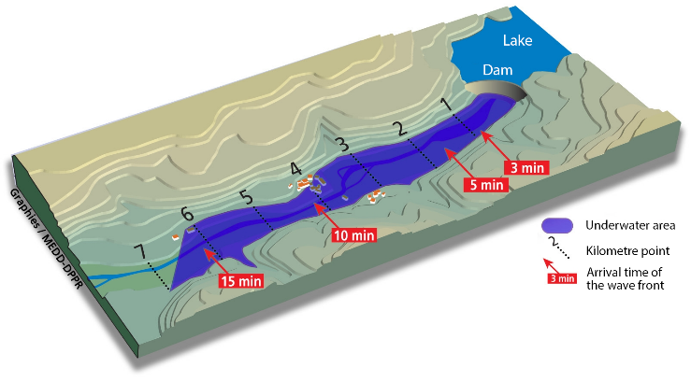In general, and as represented schematically, we represent the immersed zones according to the height of water, the various kilometre stones from the dam and the arrival times of the wave at important points.

Figure 4 - Schematic of expected dam failure mapping

As regards the software used, the various design offices remain unclear about the software they use. In the literature I have studied there are references to RUBAR and CASTOR software (Paquier, 2001). This software was developed by CEMAGREF (now IRSTEA, National Research Institute of Science and Technology for the Environment and Agriculture) and has notably evolved during the European CADAM (Concerted Action for Dam Break Waves).

The latter map represents a standard document required for the development of the hazard plan. This one is located in the south of France, near one of the largest cities of the region: Aix en Provence, a very populated area which is therefore a sensitive point concerning the risks of flooding.

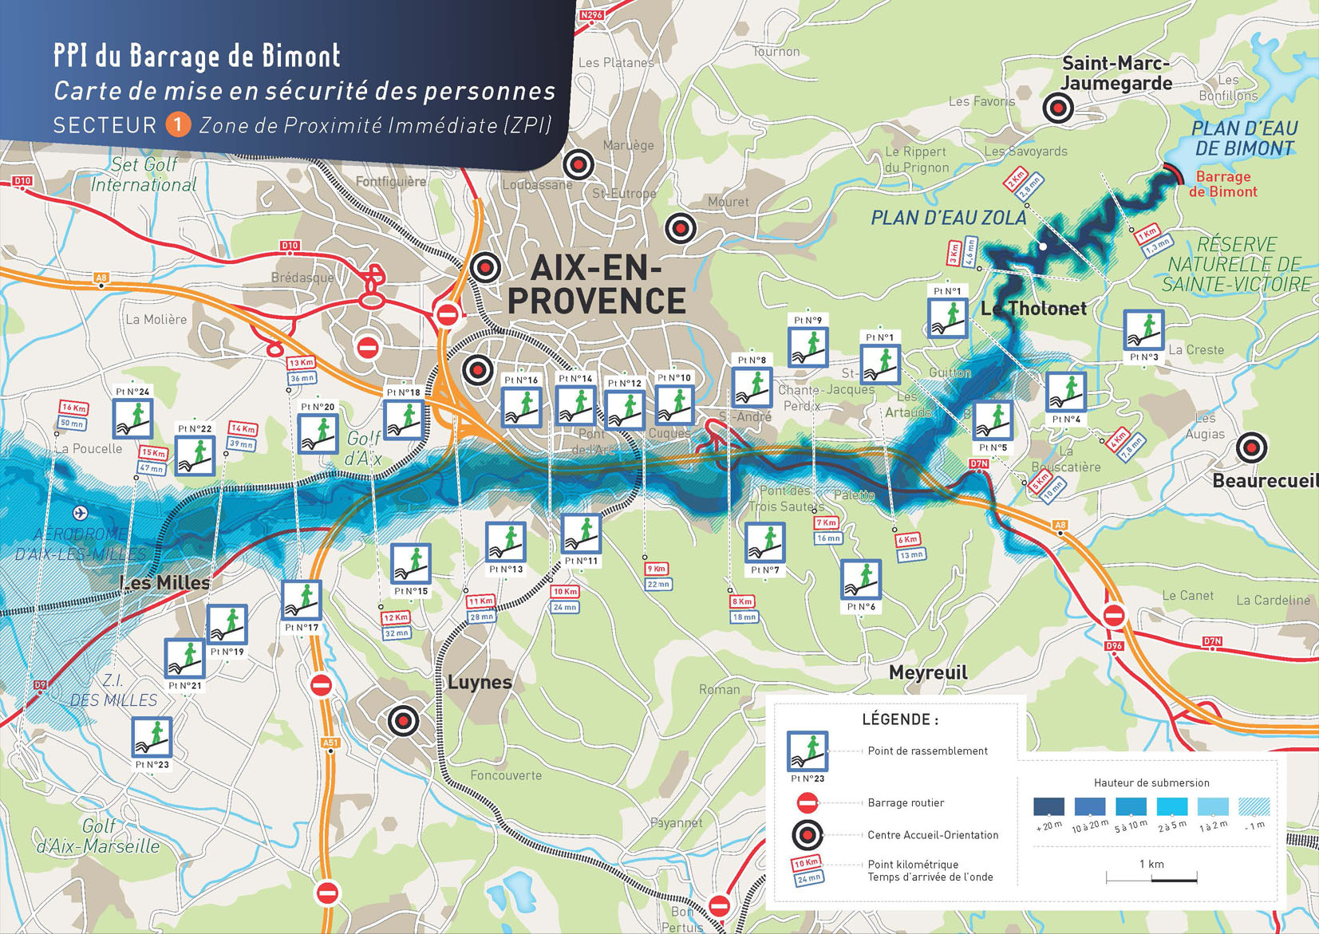

Figure 5 - Mapping of flooding and the propagation of a submergence wave, following a possible rupture of the Bimont dam, very close to the city of Aix en Provence

# 📚 Bibliography

Chapitre IV : Activités, installations et usage (Articles R214-1 à R214-132), R214-1 à R214-132 (2019).

*Le risque rupture de barrage*. (2017). D.D.R.M des Pyrénées-Orientales.

Paquier, A. (2001). *Rupture de barrage: Validation des modèles numériques du Cemagref dans le cadre de CADAM*. 12.

Décret no 2015-526 du 12 mai 2015 relatif aux règles applicables aux ouvrages construits ou aménagés en vue de prévenir les inondations et aux règles de sûreté des ouvrages hydrauliques, 2015-526 (2015).

# 🖼️ List of figures

Figure 1 - Location of dams in France (sources: MEDDTL, DGPR, IGN) 1

Figure 2 - The Petit Saut dam (Saint-Élie, Guyane) 1

Figure 3 - The Saint-Ferréol Dam (Auvergne-Rhône-Alpes, Metropolitan France) 1

Figure 4 - Schematic of expected dam failure mapping 4

Figure 5 - Mapping of flooding and the propagation of a submergence wave, following a possible rupture of the Bimont dam, very close to the city of Aix en Provence 4

Table 1 - Categorisation of French dams 1